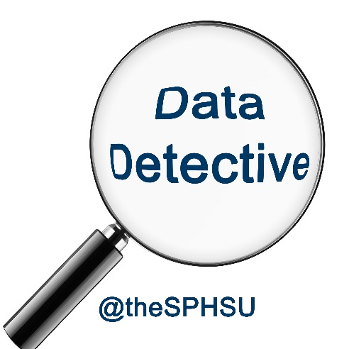**Data sharing agreement**

We, the ***Environment*** team, agree to share information with all official members of the ***Employment*** team

I agree that these data will only be used for the purposes of identifying which school is going to be hit by the hiccupping disease.

I agree that the only information that I will share is the Sharing ID and whether a school is at risk of Health / Environmental grounds.

I agree that the data will be safely stored and that I shall make no attempt to identify individuals. The Sharing ID and the Health Care data will be destroyed after use.

Signed: _______________________